Project Name: Girl and Galaxy
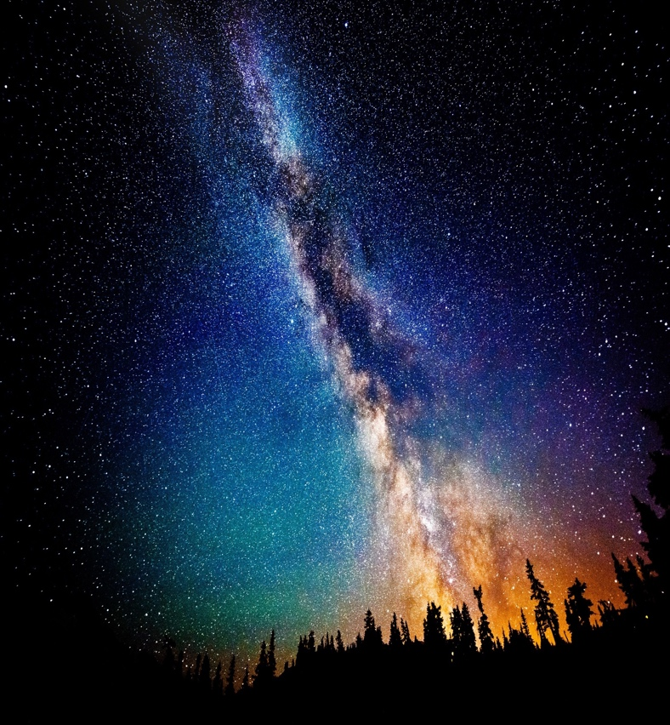
Original Image/s:

Detail the Steps taken to Enhance the Image:
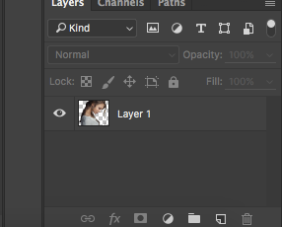
- Open the girl image in Photoshop and use Quick Selection Tool to select her. Cmd + J to make the new layer.
Then Delete the mother layer.
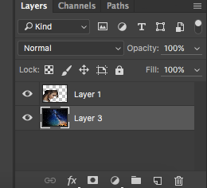
- Open the galaxy image in Photoshop and double click to unlock it, click on it and move the girl layer. Move it under the girl layer and then Cmd + T to make it bigger and turn around the girl hair to make her hair beautiful. Then click on the girl layer and change Normal to Lighten.
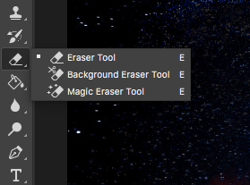
- Come back to the galaxy image move it a girl layer again. At this time i the background, Cmd + click on her layer to select her layer, then Select -> Inverse to select all. Click on the Eraser Tool and make sure it black.
Click on the galaxy layer 3 and go around her hair to delete something I do not need.
Click on the galaxy layer 2 and do the same thing.
Then Cmd + D.

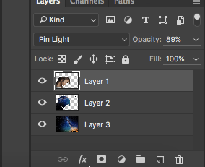
- Click on the layer 1 and change normal to Pin Light -> Opacity is 89% and click on layer 2 change to Pin Light -> Opacity is 70%.
- Move the girl to the left corner and check her hair still look good.
Final Image:
Save the file as a (1) .pdf and (2) a .jpg on your own hard drive/USB.

